**Name:** Kailan Barnes **Date:** 11/9/2021

**Lab section:** Tuesday - 007

**Show your work!!!**

**Acquire**

Week: 11

Date: March 14 Year: **2021** Data: [What is the World’s Biggest Cash Crop?](https://www.informationisbeautiful.net/visualizations/what-is-the-worlds-biggest-cash-crop/)

**Source Article/Visualization:**

From 1961-2019, which crops per region were most harvested, produced the most yield, and produced the most quantity?

<https://www.makeovermonday.co.uk/data/data-sets-2018/>

**Represent**

**Critique**

I like the comparison between the revenue of the crop to square kilometer of it planted, and the inclusion of visuals in the area chart. To improve this visualization, I want to compare the popularity to the revenue instead of the area harvested to the revenue. In the data, I also noticed there was a variable for geographical region, so I plan to make a symbol map to represent the data.

Overview- depending on the task, visualization can emphasize certain aspects of the data. Convergent thinking is a mode of critical thinking in which a person attempts to reduce complexity through analysis and synthesis. Data viz-visual representation of quantitative data in schematic form without axis.

**Mine**

What question(s) are you attempting to answer? Remove this text and highlighting before submitting your work.

How does the production of crops compare to their yield across the world?

**Filter**

|  |  |  |  |  |  |  |
| --- | --- | --- | --- | --- | --- | --- |
| Area | Domain | Element | Item | Unit | Year | Value |
| Asia | Crops | Production | Oilcrops | tonnes | 1980 | 91928361 |
| Asia | Crops | Production | Pulses, Total | tonnes | 1980 | 20521596 |
| Asia | Crops | Production | Roots and Tubers, Total | tonnes | 1980 | 2.26E+08 |
| Asia | Crops | Production | Sugar Crops Primary | tonnes | 1980 | 2.89E+08 |
| Asia | Crops | Production | Treenuts, Total | tonnes | 1980 | 1348804 |
| Asia | Crops | Production | Vegetables Primary | tonnes | 1980 | 1.42E+08 |
| Asia | Crops | Production | Cereals, Total | tonnes | 1981 | 6.57E+08 |
| Asia | Crops | Production | Citrus Fruit, Total | tonnes | 1981 | 13282616 |
| Asia | Crops | Production | Fibre Crops Primary | tonnes | 1981 | 4117368 |
| Asia | Crops | Production | Fruit Primary | tonnes | 1981 | 1.07E+08 |
| Asia | Crops | Production | Oilcrops | tonnes | 1981 | 1.04E+08 |
| Asia | Crops | Production | Pulses, Total | tonnes | 1981 | 22047879 |
| Asia | Crops | Production | Roots and Tubers, Total | tonnes | 1981 | 2.14E+08 |

**Stakeholders**

* Who is your audience? What assumptions did you make? What visualization tool/software did you use?
* The audience is executives of manage the trade and production of agricultural crops, government officials who oversee agricultural production, and diplomats who help guide trade between countries.
* I assumed the data was accurate and there are no errors in the data. I also assumed that the audience already has prior knowledge of this section of the economy.
* I used tableau to create the visualization

**What to submit:** This document in PDF format only (if you do not know how to do this, ask).

**Choose the best layout** for your makeover visualization: Portrait or Landscape, Remove the page of the layout that you DO NOT choose. No blank pages!

**NEW Sketch your Makeover**

In the space below, sketch out your ideas for refined visualization. You must use pen/pencil and paper to sketch out your idea, then take a photo of your sketch and include it in the space below. 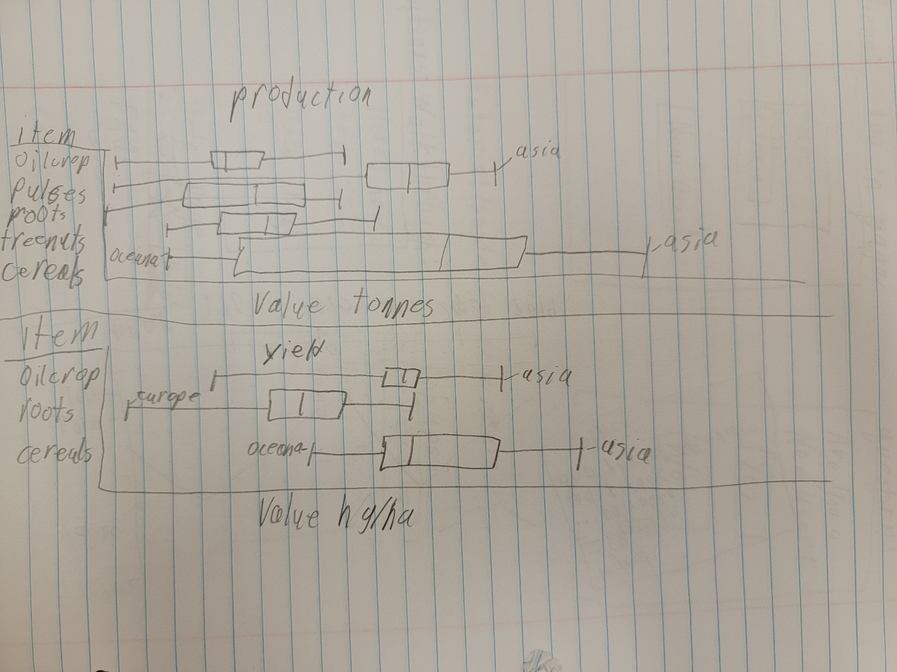

**Refine (Makeover – Landscape view)**

Two box and whisker plots that compare the production and yield of crops around the world.

**Resources**

Data Visualization Checklist:

<http://stephanieevergreen.com/wp-content/uploads/2016/10/DataVizChecklist_May2016.pdf>

How to give constructive criticism:

<https://personalexcellence.co/blog/constructive-criticism/>

Sample Makeovers

<https://www.makeovermonday.co.uk/gallery/>

**Grading Rubric**

|  |  |  |  |
| --- | --- | --- | --- |
| **Excellent**  **(11-15 pts)** | **Good**  **(6 -10 pts)** | **Fair**  **(2-5 pts)** | **Needs Improvement (0 - 1 pt)** |
| Meets **ALL** or most of these: Makeover is esthetically pleasing (color, perception), best practices followed (insightful), Correct dataset downloaded; provided an interesting point of view of the data; critiqued previous makeover, critique is constructive (indicates one thing that is done well, and one thing that could be done differently, what will be done to improve the visualization), assumptions (more than one) are listed. | Meets **MOST** of these: Makeover is esthetically pleasing (color, perception), best practices followed (insightful), Correct dataset downloaded; provided an interesting point of view of the data; critiqued previous makeover, critique is constructive (indicates one thing that is done well, and one thing that could be done differently, what will be done to improve the visualization), assumptions (more than one) are listed. | Consistently meets **SOME** of these: Makeover is esthetically pleasing (color, perception), best practices followed (insightful), Correct dataset downloaded; provided an interesting point of view of the data; critiqued previous makeover, critique is constructive (indicates one thing that is done well, and one thing that could be done differently, what will be done to improve the visualization), assumptions (more than one) are listed. | Little to no evidence of the understanding of the data visualization process.  Lackluster makeover or no makeover.  Little effort. |
| Sketch included: hand drawn [5 pts] | Sketch included, but was generated by computer [2 pts] | No sketch included. [0 pts] |  |
| Makeover Monday Assessment Completed  [5 pts] | Makeover Monday Assessment not completed [0 pts] |  |  |